PROJECT REPORT

1. INTRODUCTION:

* 1. OVERVIEW:

First I created an EMPATHY MAP . A map has four quadrants - says, Thinks, Does and Feels. Why we are subscribe the YouTube channel and what are difficulties subscribe in YouTube channel. This are the thing shown in four quadrants. Next I created the BRAINSTROME. Our team take a problem statement and we discuss how to solve that problem. Our team problem statement is “ list of most- subscribed YouTube channels”. Then I created my data analysis- Dashboard and Story. Next step I published my Dashboard and story in tableau public.

1.2 Purpose:

A subscriber to a channel on the American video sharing platform YouTube is a user who has chosen to receive the channel’s content by clicking on that channel’s “Subscribe” button , and each user’s subscription feed consists of video published by channels to which the user is subscribed.

PROBLEM DEFINITION & DESIGN THINKING

2.1 EMPATHY MAP

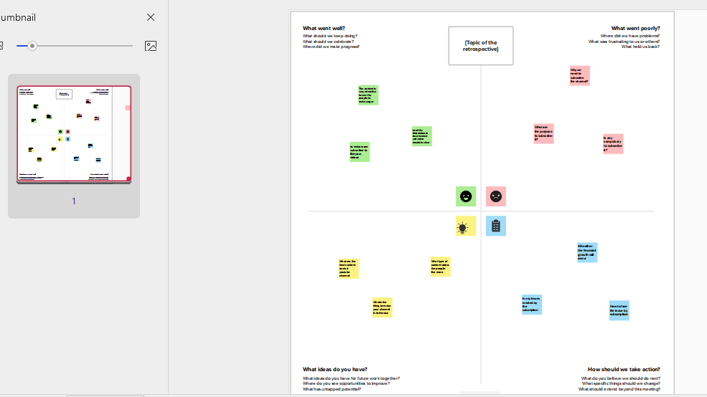

2.2 BRAIN STORMING

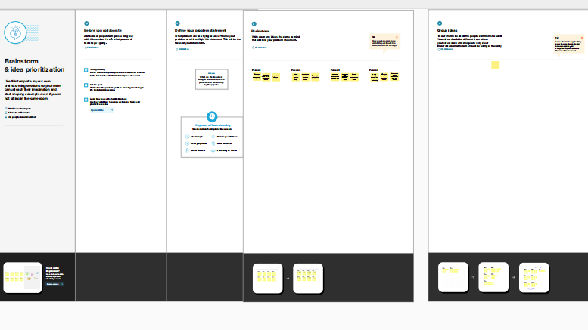

RESULT:

DASHBOARD

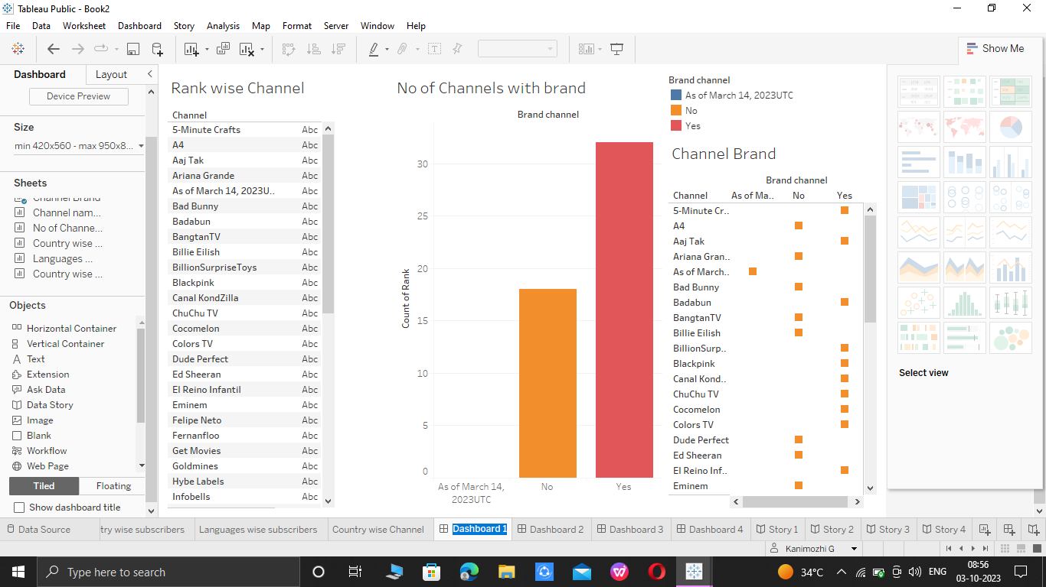

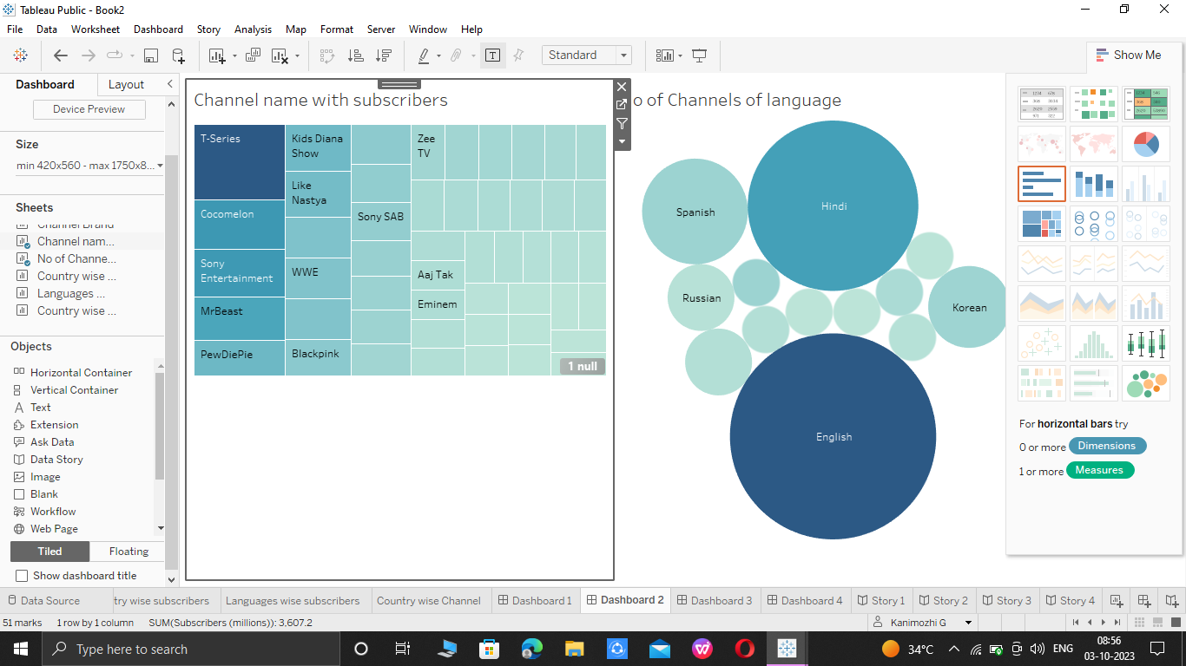

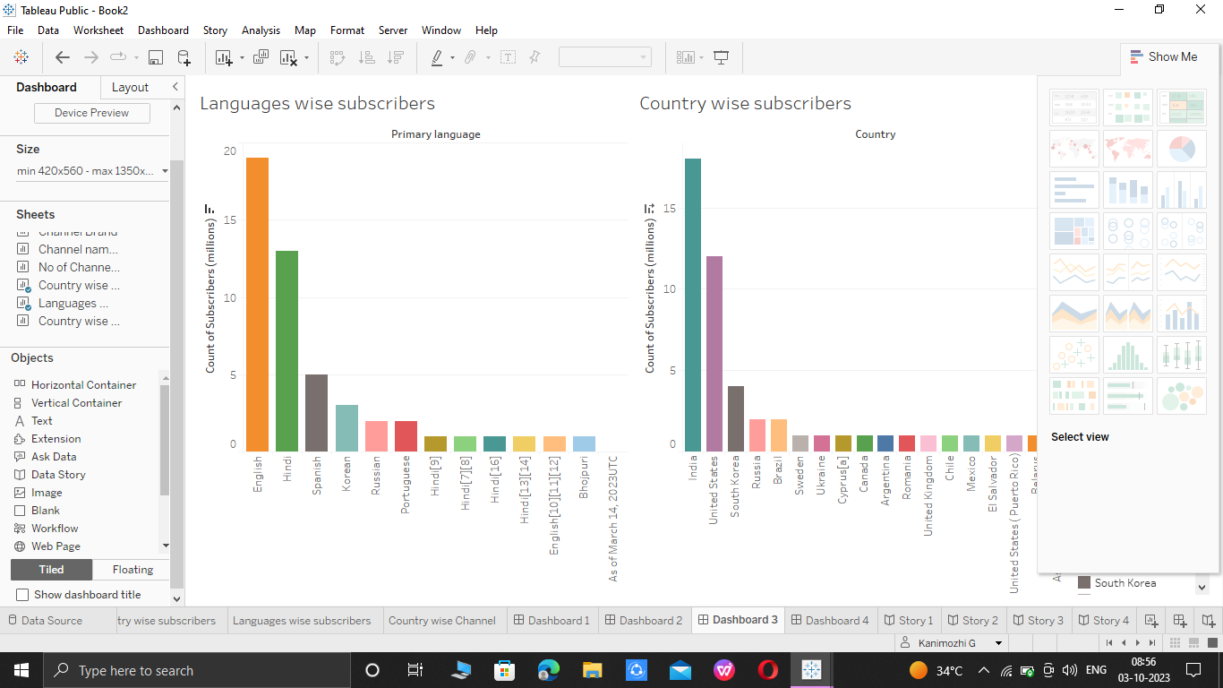

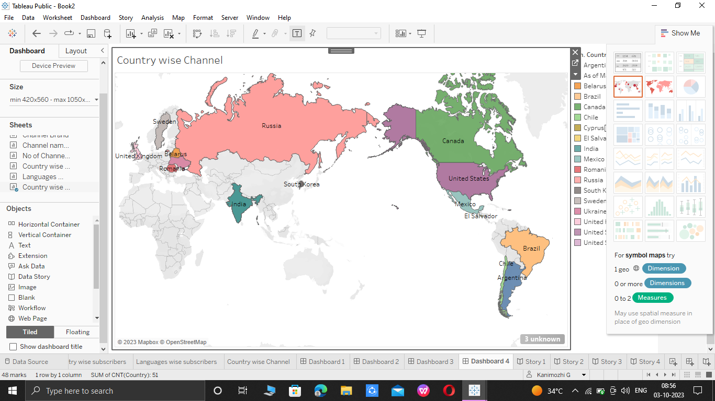

STORY 1

CHANNEL DETAILS

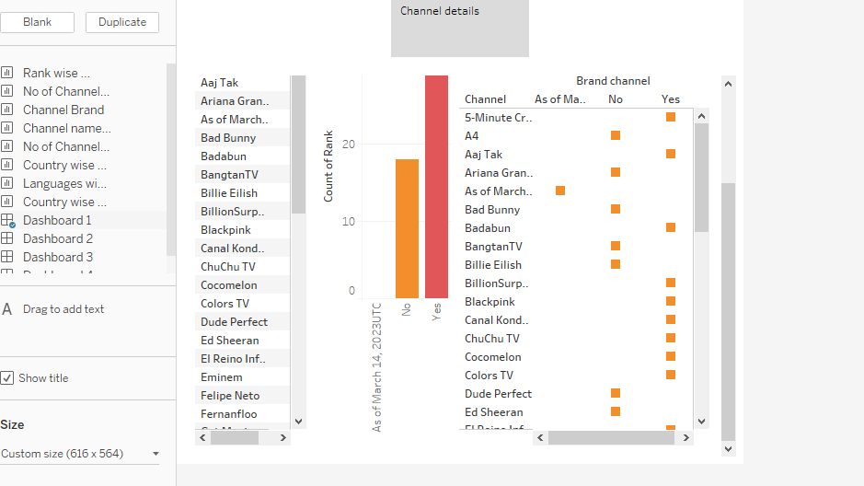

STORY 2

LIST OF CHANNELS WITH NO OF SUBSCRIBERS AND LANGUAGE

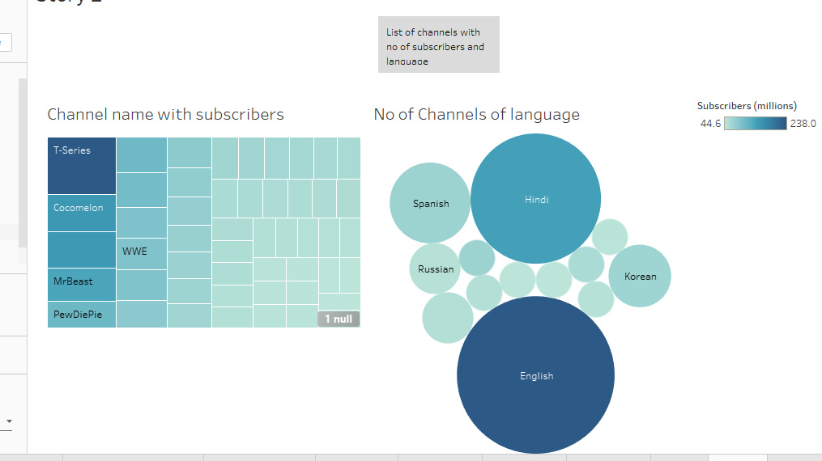

STORY 3

LANGUAGE AND COUNTRY WISE SUBSCRIBERS

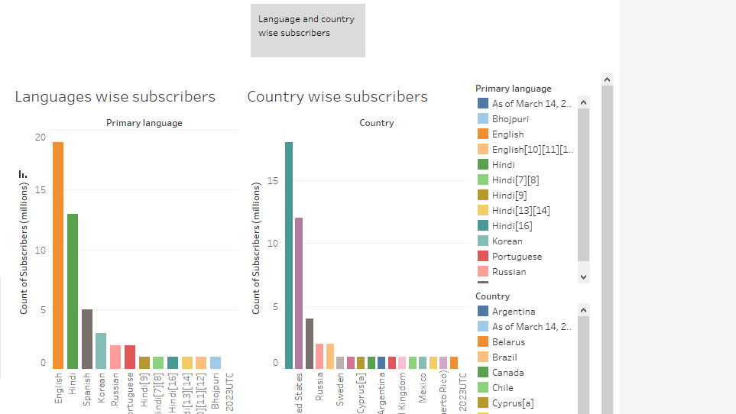

STORY 4

COUNTRY WISE PRIMARY LANGUAGE NO OF SUBSCRIBERS TOTAL NO OF SUBSCRIBERS

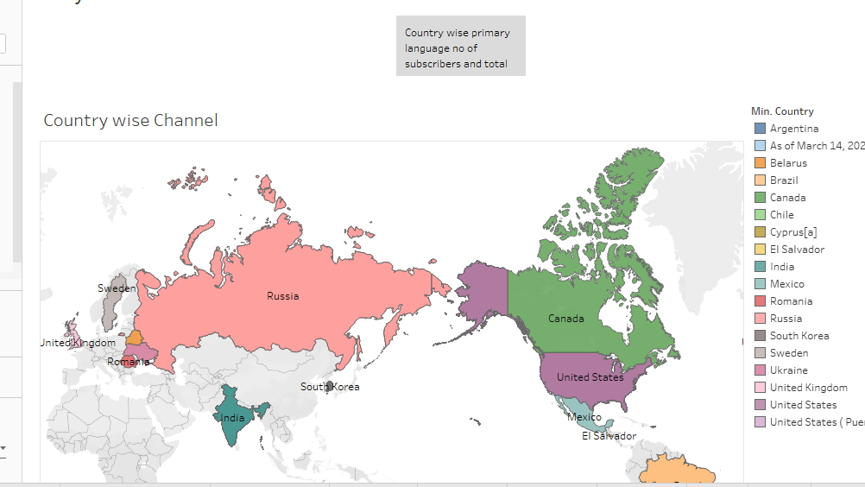

ADVANTAGES &DISADVANTAGES

ADVANTAGES:

\* YouTube as an information disseminating platform for students

\* YouTube’s user - friendliness

\* YouTube for brand promotion

\* YouTube benefits talented people

\* Easy Earning is at the very top of the list of YouTube benefits for Vloggers

DISADVANTAGES:

\* Ads - a drawback of YouTube for the audience

\* A lot of distraction

\* Obscenity - one of the biggest drawback that YouTube

\* Defamation and Bullying

\* Making money isn’t that easy

APPLICATION:

\* YouTube is a web application.

\* It’s useful for money earning.

\* Become popularity.

\* We can learn new information for YouTube

CONCLUSION:

Indian record label T-Series is the most subscribed channel with over 250 million subscribers as of September 2023. YouTube can find valuable inspiration for their own content by a look at the strategies of the top channels.

FUTURE SCOPE:

YouTube will continue to be where people go for informative and educational videos. As more innovative technology comes out, YouTube will evolve with it. By 2022, it will be even more powerful, and we’ll see many new changes that are sure to revolutionize marketing as a whole.